**SOURCE CODE**

**1)**

#include<stdio.h>

#define MAX 10

#define CN count++

int count=0;

int Bsearch(int arr[],int low, int high,int key)

{

int mid;

while(low<high)

{

CN;

mid=(low+high)/2;CN;

if(key==arr[mid])

{

CN;CN; return mid;

}

else if(key<arr[mid])

{

CN;CN;high=mid-1;

}

else

{

CN; low=mid+1;

}

}

CN;return -1;

}

int main()

{

int arr[MAX],n,i,key;

printf("ENTER THE NUMBER OF ELEMENTS: ");

scanf("%d",&n);

printf("ENTER THE ELEMENTS INTO YOUR ARRAY:\n");

for(i=0;i<n;i++)

{

printf("a[%d]: ",i);

scanf("%d",&arr[i]);

}

printf("ENTER THE SEARCH KEY: ");

scanf("%d",&key);

int x=Bsearch(arr,0,n,key);

CN;

if(x==-1)

printf("ELEMENT NOT FOUND IN ARRAY\n");

else

printf("ELEMENT FOUND AT %d LOCATION\n",x);

printf("\nSTEP COUNT=%d\n",count);

}

**OUTPUT**

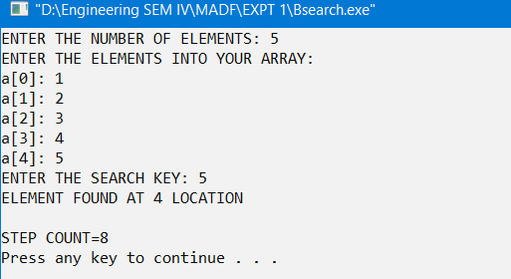

**2)**

#include<stdio.h>

#define CN count++

#define MAX 10

int count=0;

int Bsearch(int arr[],int low, int high,int key)

{

if(low<high)

{

CN;

int mid=(low+high)/2;CN;

if(arr[mid]==key)

{

CN;CN; return mid;

}

else if(key<arr[mid])

{

CN;CN; return(Bsearch(arr,low,mid-1,key));

}

else

{

CN; return(Bsearch(arr,mid+1,high,key));

}

}

CN; return -1;

}

int main()

{

int arr[MAX],n,i,key;

printf("ENTER THE NUMBER OF ELEMENTS: ");

scanf("%d",&n);

printf("ENTER THE ELEMENTS INTO YOUR ARRAY:\n");

for(i=0;i<n;i++)

{

printf("a[%d]: ",i);

scanf("%d",&arr[i]);

}

printf("ENTER THE SEARCH KEY: ");

scanf("%d",&key);

int x=Bsearch(arr,0,n,key);

CN;

if(x==-1)

printf("ELEMENT NOT FOUND IN ARRAY\n");

else

printf("ELEMENT FOUND AT %d LOCATION\n",x);

printf("\nSTEP COUNT=%d\n",count);

}

**OUTPUT**

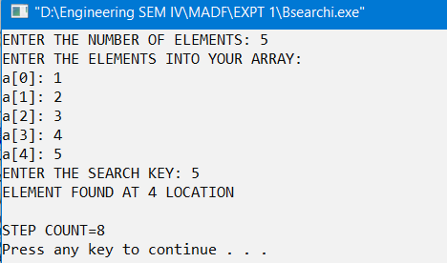

**SOURCE CODE**

**1)**

#include<stdio.h>

#define CN cnt++

int cnt=0;

int a[20];

void maxmin(int i, int j, int *max, int *min)

{

int mid, max1, min1;

if(i==j){

CN;

*min=a[i];CN;

*max=a[i];CN;

}

else if(i==j-1)

{

CN;

if(a[i]<a[j])

{

CN;

*max=a[j];*min=a[i];CN;

}

else

{

*max=a[i];*min=a[j];CN;

}

}

else{

mid=(i+j)/2;CN;

maxmin(i, mid, max, min);

maxmin(mid+1, j, &max1, &min1);

if(*max<max1)

{

CN;

*max=max1; CN;

}

if(*min>min1)

{

CN;

*min=min1; CN;

}

}

}

int main()

{

int n, max, min,i;

printf("ENTER THE SIZE OF THE ARRAY: ");

scanf("%d",&n);

printf("ENTER THE ELEMENTS\n");

for(i=0;i<n;i++)

{

printf("A[%d]: ",i+1);

scanf("%d",&a[i]);

}

maxmin(0, n-1, &max, &min);

printf("MAX= %d",max);

printf("\nMIN= %d\n",min);

printf("STEP COUNT= %d",cnt);

return 0;

}

**OUTPUT**

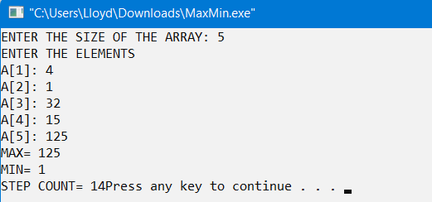

**SOURCE CODE**

**1)**

#include<stdio.h>

#define CN count++

#define MAX 10

int count=0;

void swap(int arr[],int i, int j)

{

int temp= arr[i];CN;

arr[i]=arr[j];CN;

arr[j]=temp;CN;

}

int partition(int arr[], int i, int j)

{

int piv=i; CN;

i=i+1;CN;

do{

CN;

while(arr[i]<=arr[piv])

{CN;i++;CN;}

while(arr[j]>arr[piv])

{CN;j--;CN;}

if(i<j)

{CN;swap(arr,i,j);CN;}

}while(i<j);

swap(arr,piv,j);CN;

CN;return j;

}

void QuickSort(int arr[], int low, int high)

{

int p;

if(low<high)

{

CN;

p=partition(arr,low,high);CN;

QuickSort(arr,low,p-1);CN;

QuickSort(arr,p+1,high);CN;

}

}

int main()

{

int arr[MAX], i,n;

printf("ENTER THE VALUE OF N: ");

scanf("%d",&n);

printf("ENTER THE ELEMENTS INTO YOUR ARRAY:\n");

for(i=0;i<n;i++)

{

printf("A[%d]: ",i);

scanf("%d",&arr[i]);

}

QuickSort(arr,0,n-1);

printf("ARRAY AFTER SORTING: \n");

for(i=0;i<n;i++)

{

printf("%d ",arr[i]);

}

printf("\nSTEP COUNT: %d\n",count);

}

**OUTPUT**

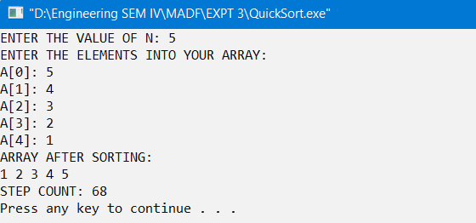

**SOURCE CODE**

**1)**

#include<stdio.h>

#define MAX 10

#define CN count++

int count=0;

void merge(int arr[],int sortArr[],int l1, int h1, int l2, int h2)

{

int ThirdArr=l1;CN;

while(l1<=h1&&l2<=h2)

{

CN;

if(arr[l1]<=arr[l2])

{CN;sortArr[ThirdArr++]=arr[l1++];CN;}

else

{CN;sortArr[ThirdArr++]=arr[l2++];CN;}

}

while(l1<=h1)

{CN;sortArr[ThirdArr++]=arr[l1++];CN;}

while(l2<=h2)

{CN;sortArr[ThirdArr++]=arr[l2++];CN;}

}

void copy(int arr[],int temp[],int low, int high)

{

int i;

for(i=0;i<=high;i++)

{CN;arr[i]=temp[i];CN;}

}

void MergeSort(int arr[],int low, int high)

{

if(low<high)

{

CN;

int mid=(low+high)/2,temp[MAX];CN;

MergeSort(arr,low,mid);CN;

MergeSort(arr,mid+1,high);CN;

merge(arr,temp,low,mid, mid+1, high);CN;

copy(arr,temp,low,high);CN;

}

}

int main()

{

int i,n,arr[MAX];

printf("ENTER THE SIZE OF YOUR ARRAY: ");

scanf("%d",&n);

printf("ENTER ELEMENT INTO YOUR ARRAY: \n");

for(i=0;i<n;i++)

scanf("%d",&arr[i]);

MergeSort(arr,0,n-1);

printf("THE ARRAY AFTER SORTING: \n");

for(i=0;i<n;i++)

printf("%d ",arr[i]);

printf("\nSTEP COUNT: %d\n",count);

}

**OUTPUT**

